Confluence

1.Creating Space In Confluence :

Click on Create Space

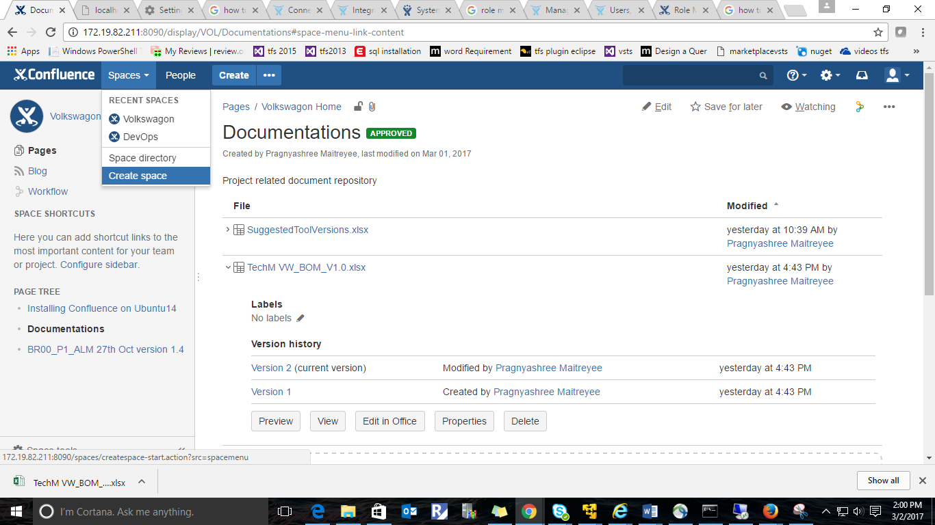

2.Creating Pages in required Space

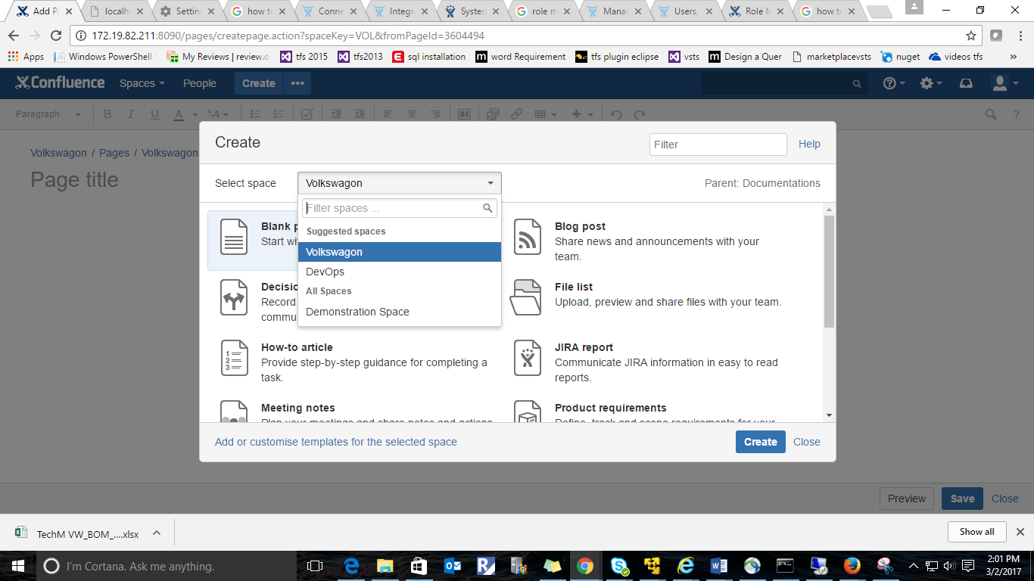

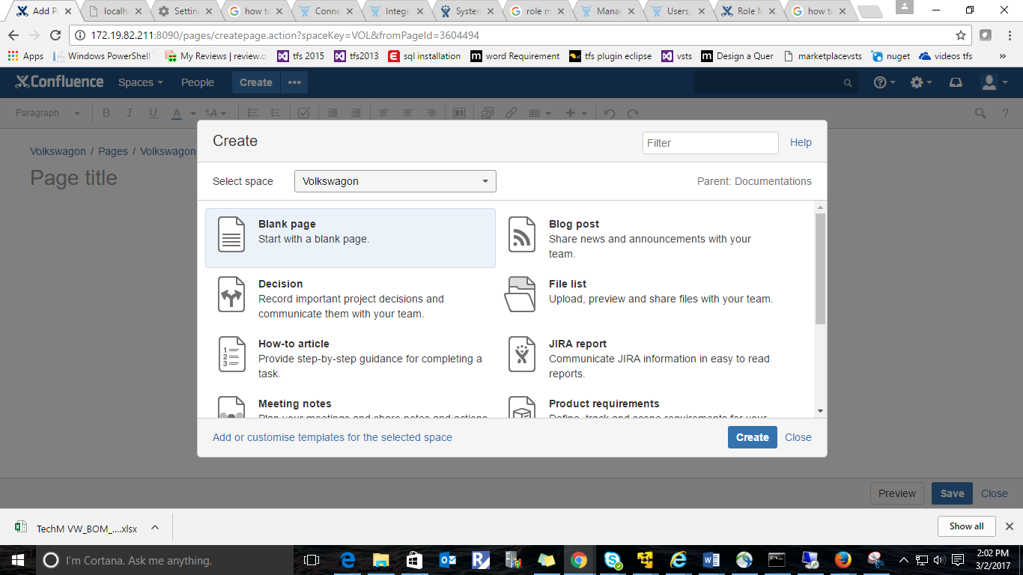

3.Versioning in Confluence:

Uploaded word document   [TechM VW_BOM_V1.0.xlsx](http://172.19.82.211:8090/download/attachments/3604494/TechM%20VW_BOM_V1.0.xlsx?api=v2)(version1).After making changes in that document uploaded same document again(Version2)

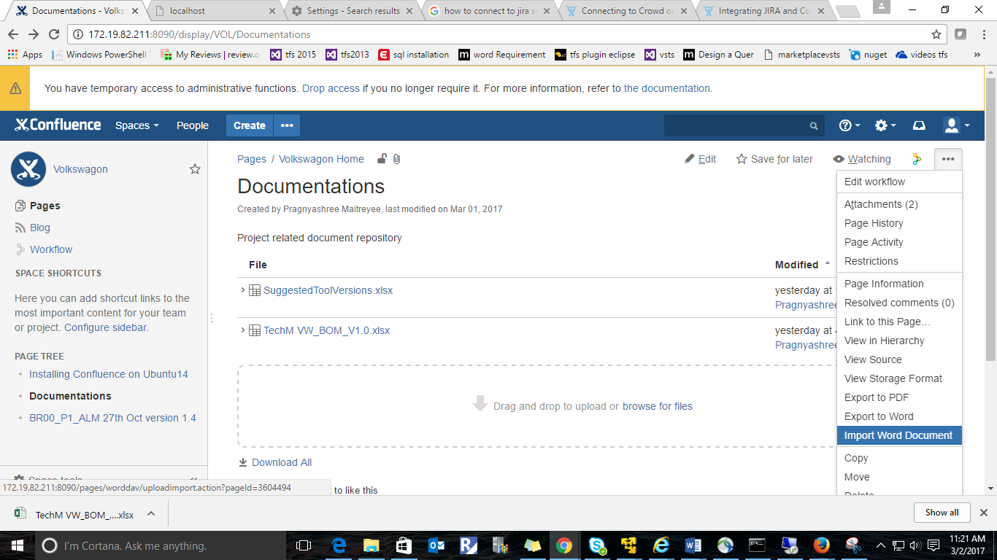

In the below screenshot we can see version1 and version2 of [TechM VW_BOM_V1.0.xlsx](http://172.19.82.211:8090/download/attachments/3604494/TechM%20VW_BOM_V1.0.xlsx?api=v2)

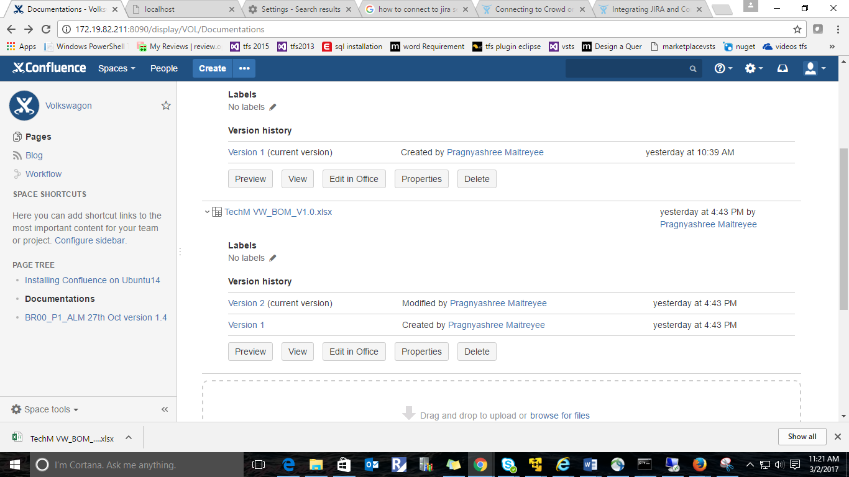

3.Comala Workflow plugin: Comala workflows gives full document management control in Confluence through approvals, tasks and workflows.Set Customized workflows to create,review,approve and publish content –minus the complex programming languages

Download comala Workflow Plugin from market place(used free trial version but it should be paid)

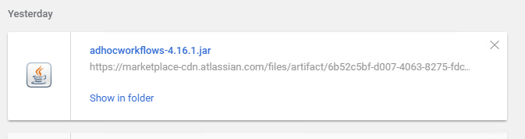

Click on add-ons

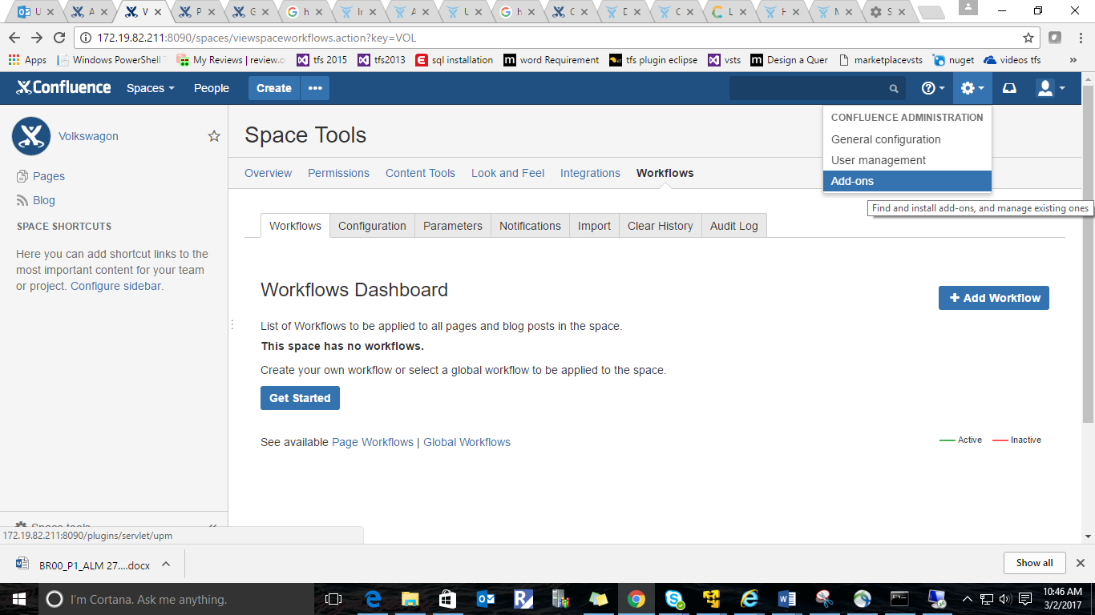

Upload plugin downloaded

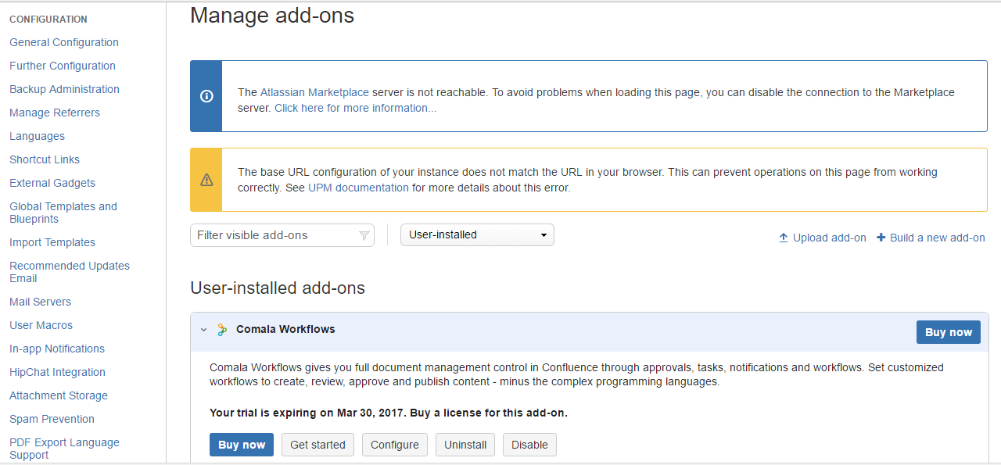

Below screenshot shows workflows in this comala plugin and we can also create workflow.

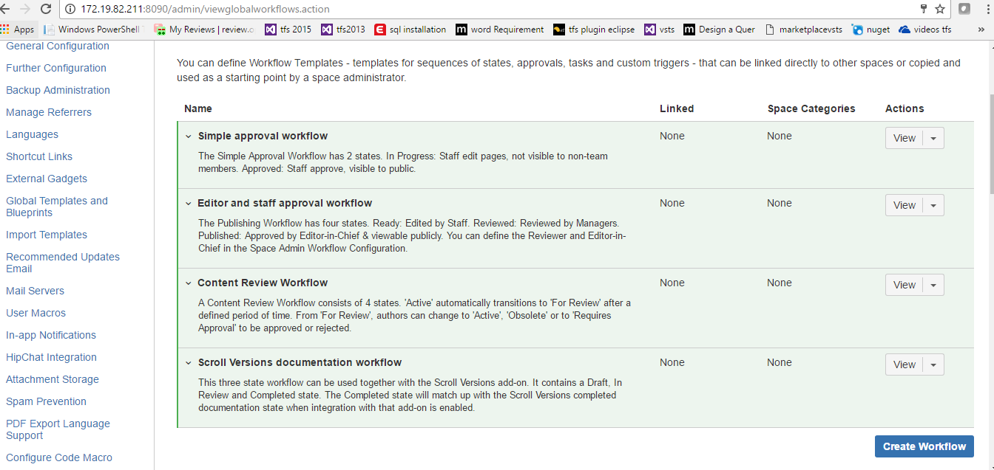

We can customize those workflow status.

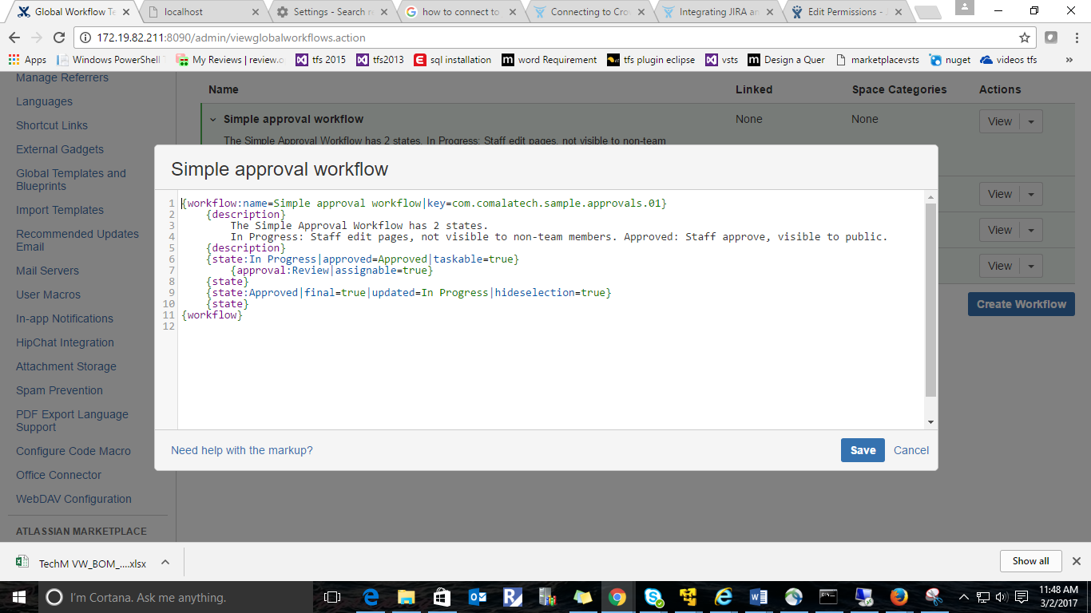

Click on add page workflow (For Documentation page) in Comala Workflows

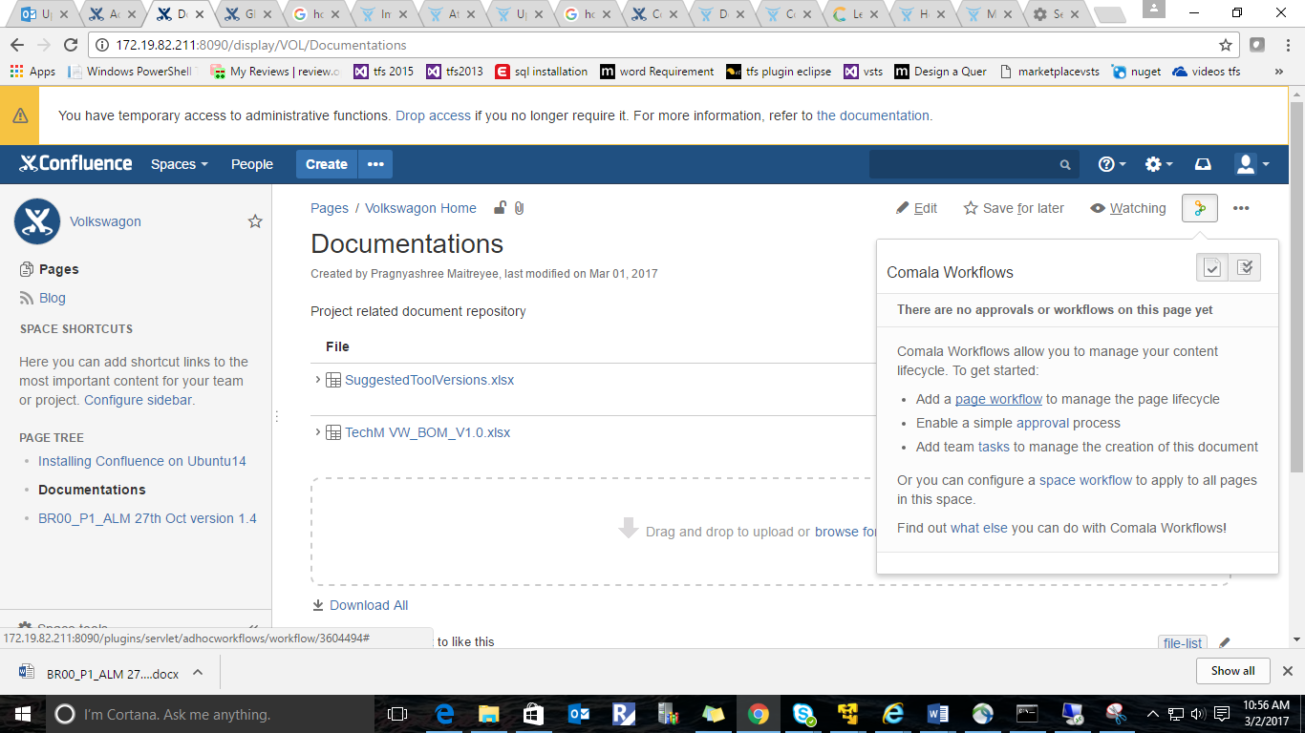

In the below screen shot we can see types of workflows. Selected a Sample approval workflow( for Documentation page)

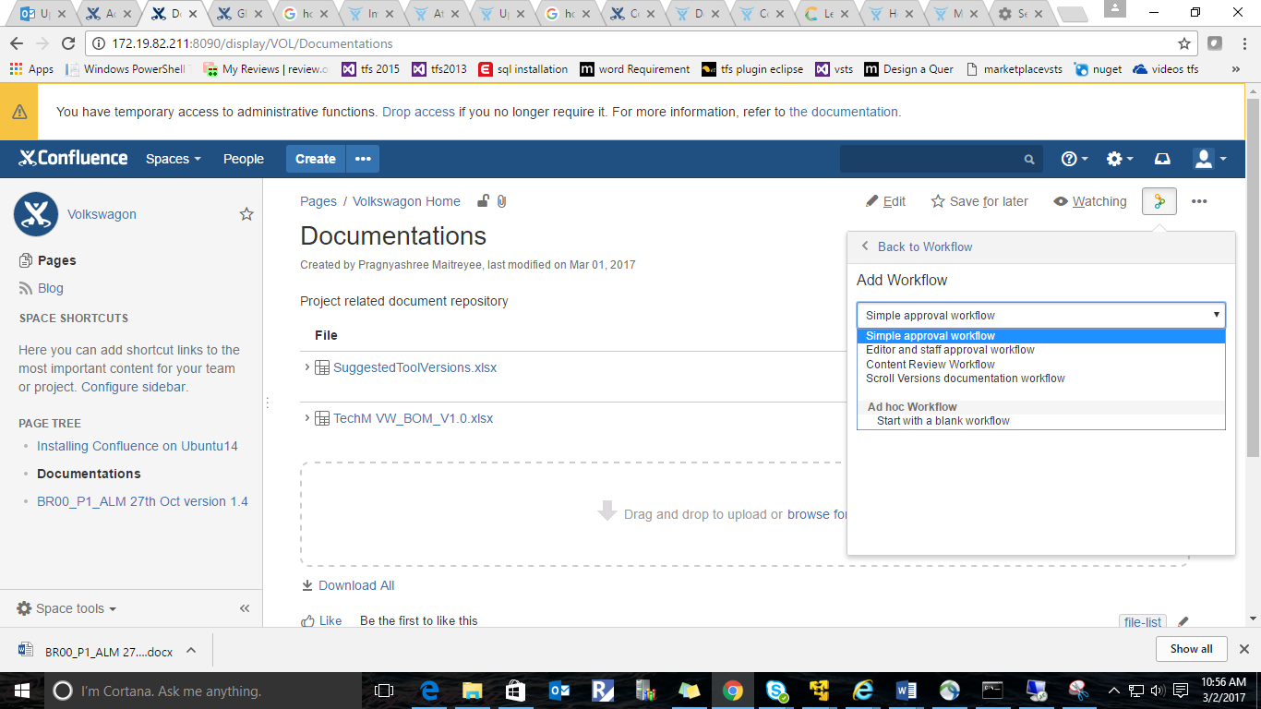

Iniatially Documentation page is in (IN PROGRESS) state

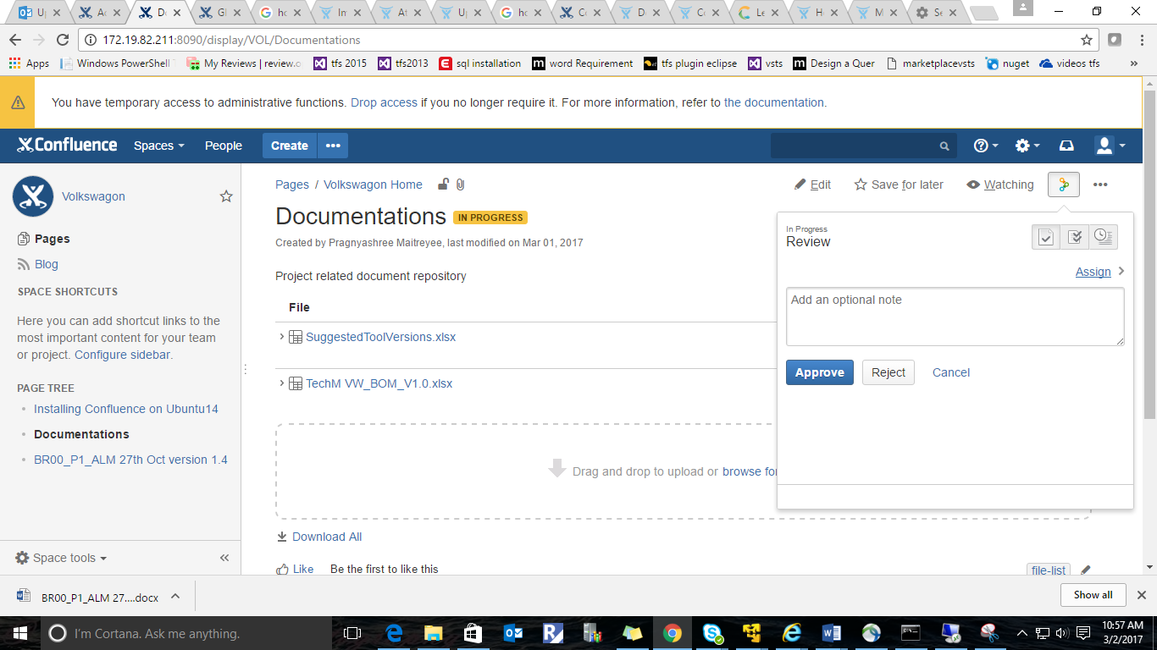

Admin(Pragnyashree) had assigned an user namely Jayasree(user) to review the document

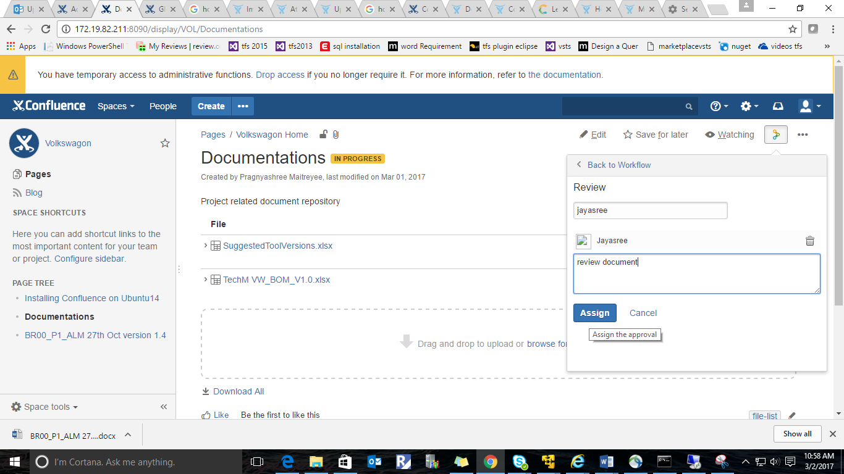

When User(Jayasree) logged into her account she will get below notification.

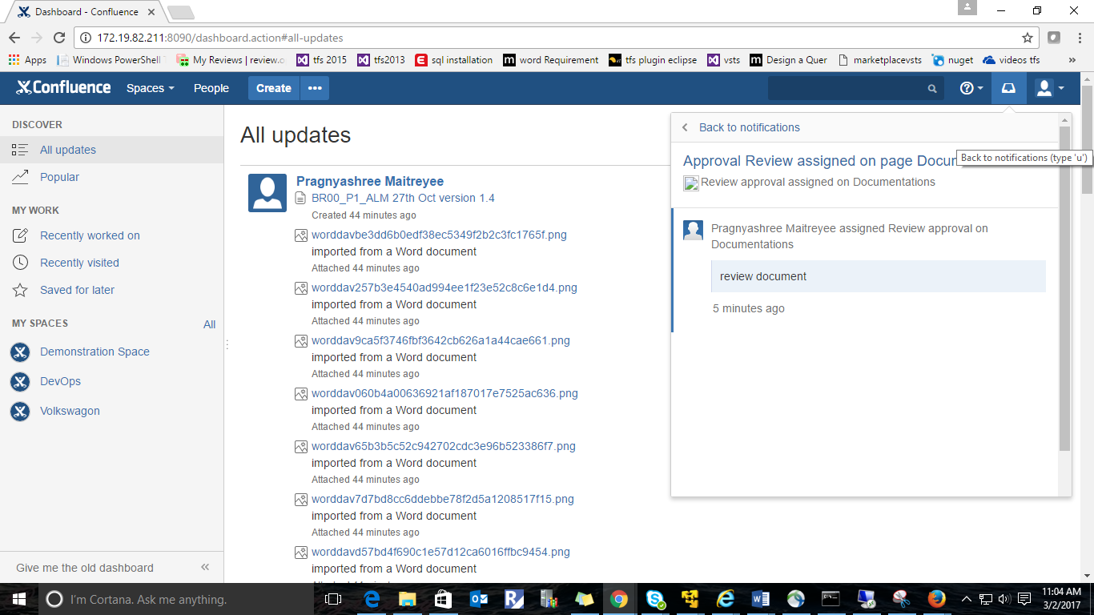

Go to My Comala Workflows Tasks and click on review

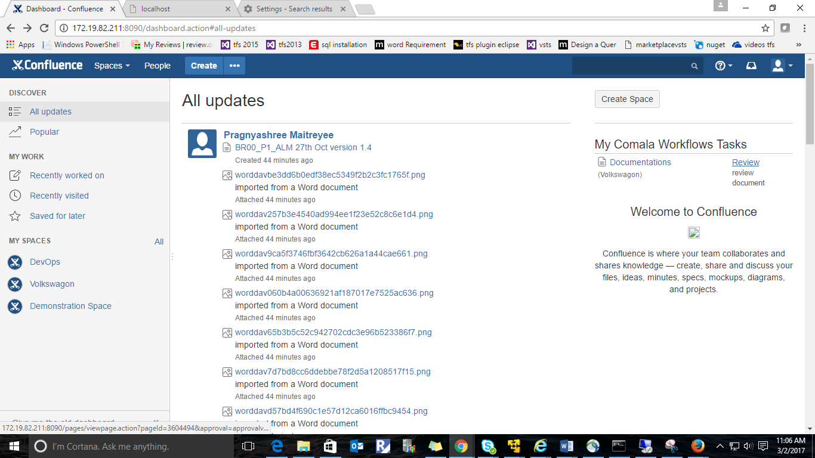

Review the document.

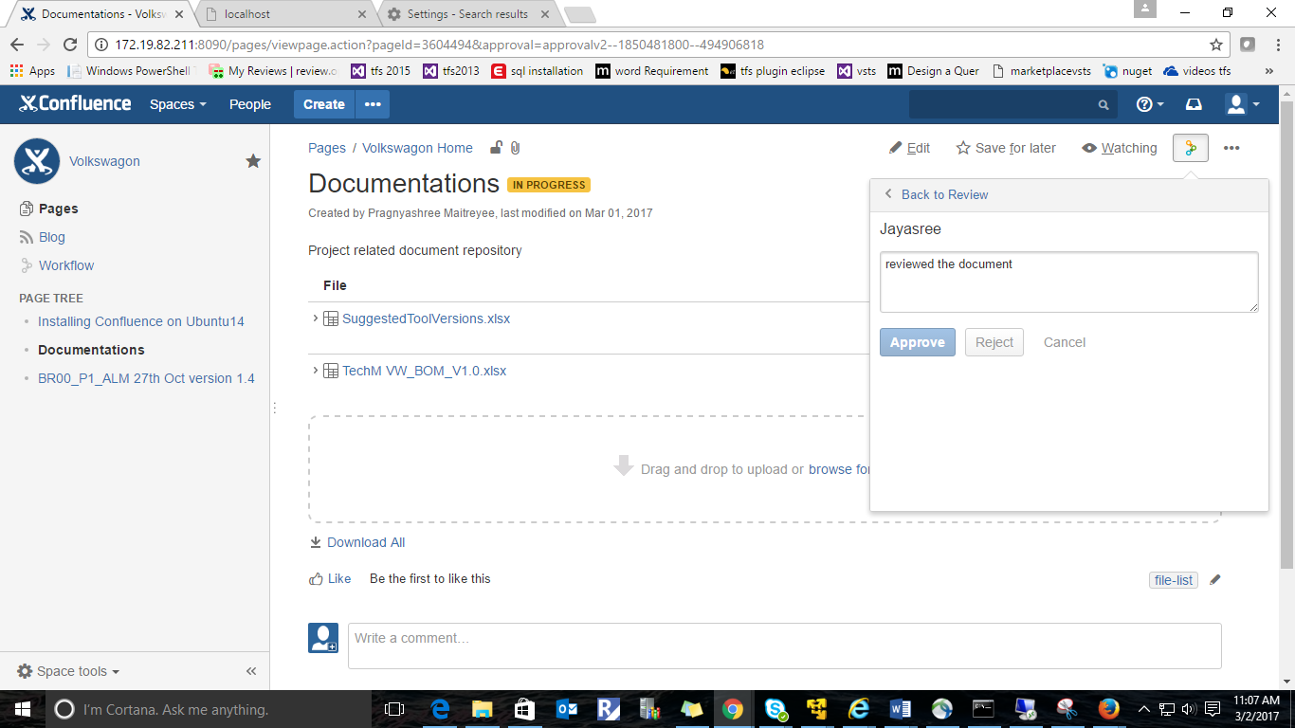

Approve the page.

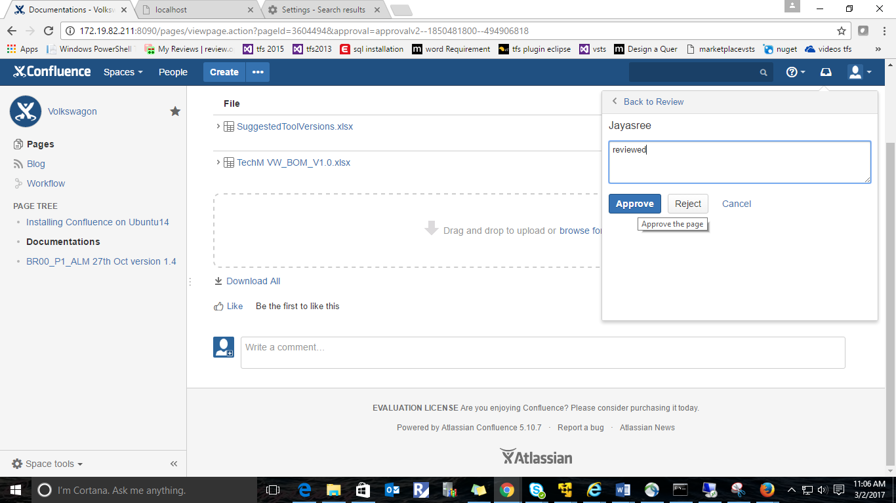

Then the Documentations page will go to Approved State .we can see it in the below screen shot

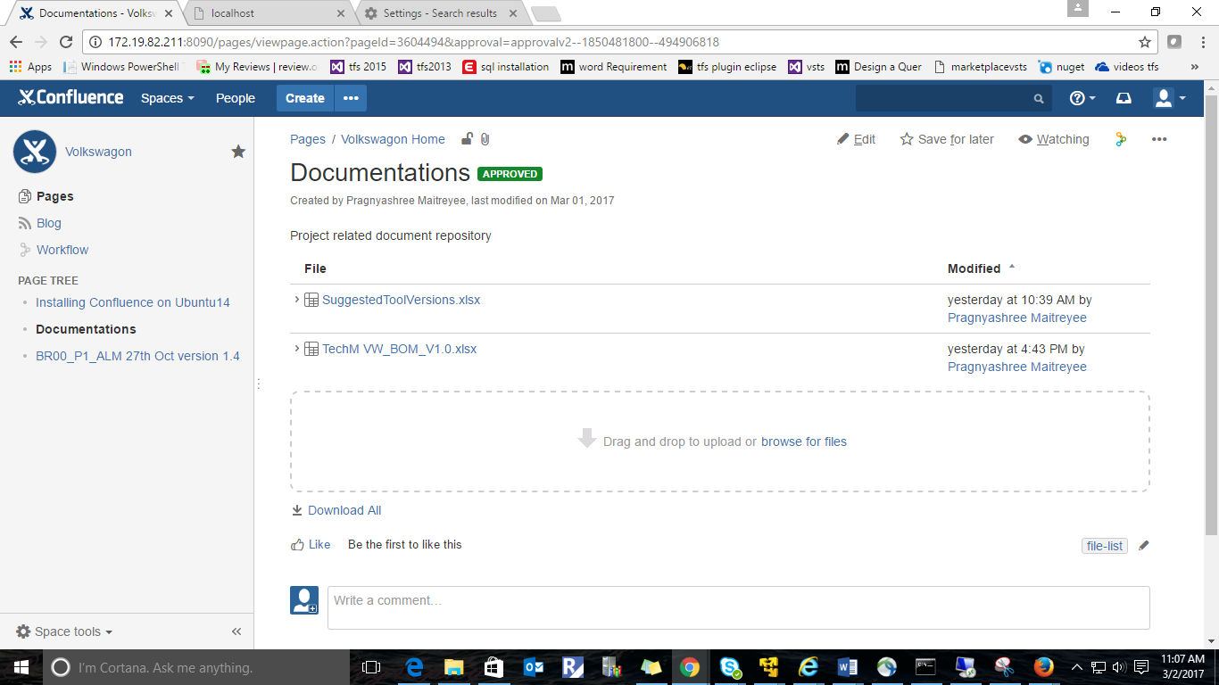

In the below screen shot we can see the sample workflow generated(In Progress to Approved)

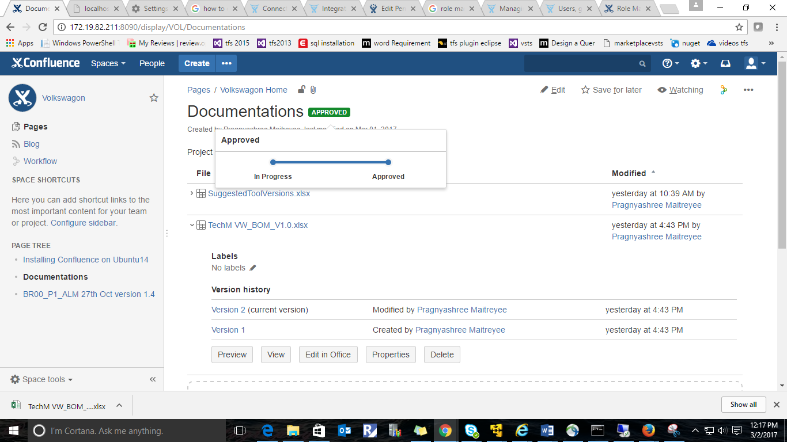

In Admin Page we will get notification if status changed to Approved State.

